**ANALYSING HOUSING PRICES IN METROPOLITAN**

**AREAS OF INDIA**

**1.Introduction**

This project titled “Analyzing Housing Prices Metropolitan Areas of India aimed to analyze spending behavior and identify opportunities for growth through the the use of Tableau.Since the inception of the theory and idea of development , the common features that emerged in different point of time is the development gap that different parts of the world also among various parts of country in a particular time period. Traditional development theories believed that agriculture, industrialization, are significant growth ,development.

* 1. **Overview**
     1. **Objectives**

This data set comprises data that was scraped. It includes:

* Collection of prices of new and resale houses located in the metropolitan areas of India
* The amenities provided for each house
* Houses prices,rents,construction costs, wages, VECM,co-integration.
  + 1. **Methodology:**

* **Data collection** :

In each zone for every category,the average price was obtained by taking average of all prices pertaining to that category in the zone.

* **Data cleaning and integration** :

Processed and integrated raw data to create a unified data based suitable for analysis..

* **Data analysis:**

Utilized tableau for in depth analysis, generating visualizing to explore spending patterns, correlations, and outliers.

* **Insights generation:**

With 40 explanatory variables describing various aspects of new and resale houses in the metropolitan ares of India , one can predict the final price of houses in these regions.

**Empathy map**

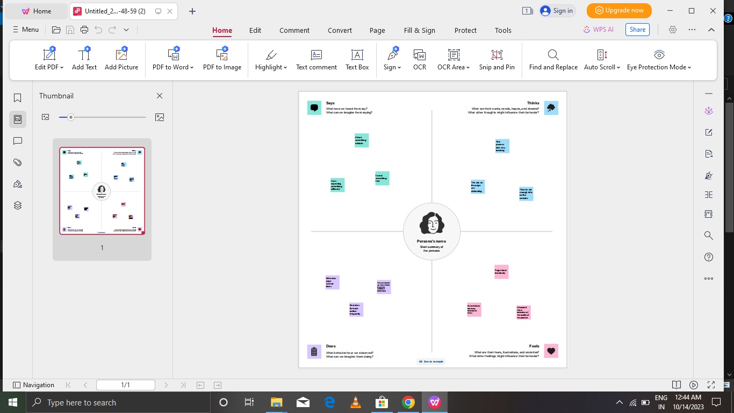

**2.2 Ideation & brainstorming map**

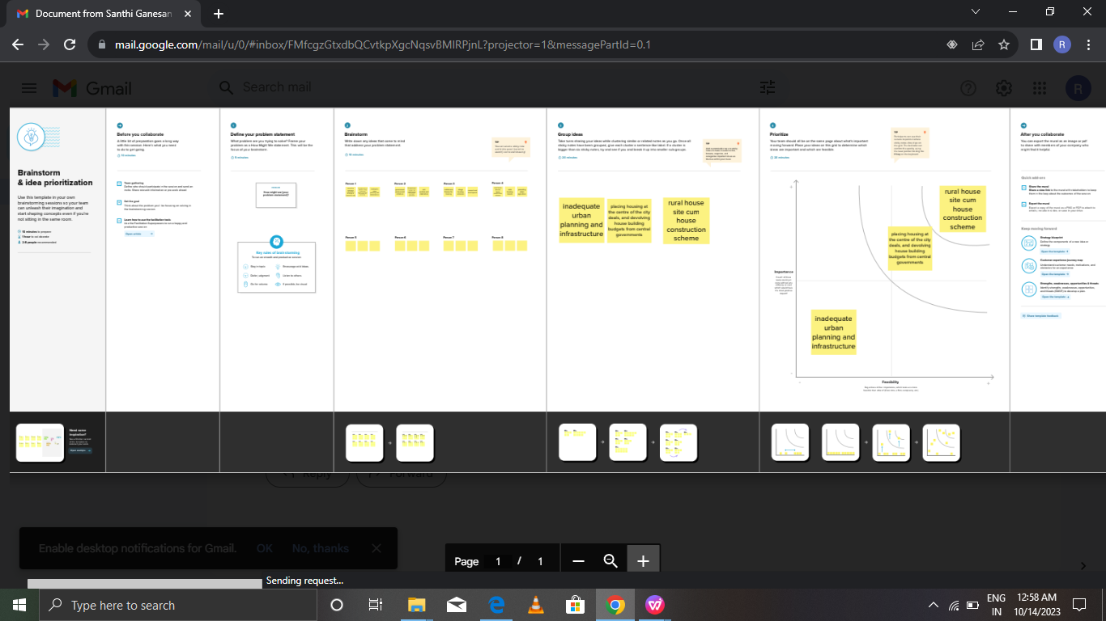

1. **RESULT**

It is typicality outlines the projects objectives, scope , methodology, progress, finding , and outcomes.A project report often includes details about the projects goals, activities, timelines, resources used, challenge faced and the results achieved. This paper analyzes whether the law of one price loop holds in the housing market of fifteen metropolitan areas in India , namely Delhi , Mumbai , Chennai. The house prices in one location in India cannot impose a competitive constraint on house prices in other location and as such a home owner can freely set the price of this house.

* 1. **Visualizations**
* **Metropolitan**

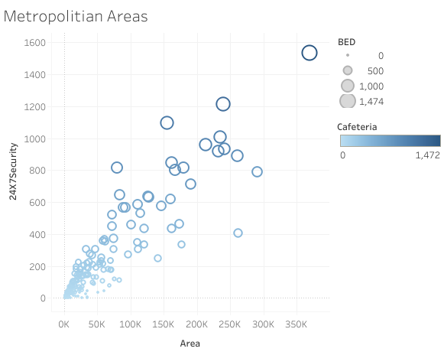**Housing prices**

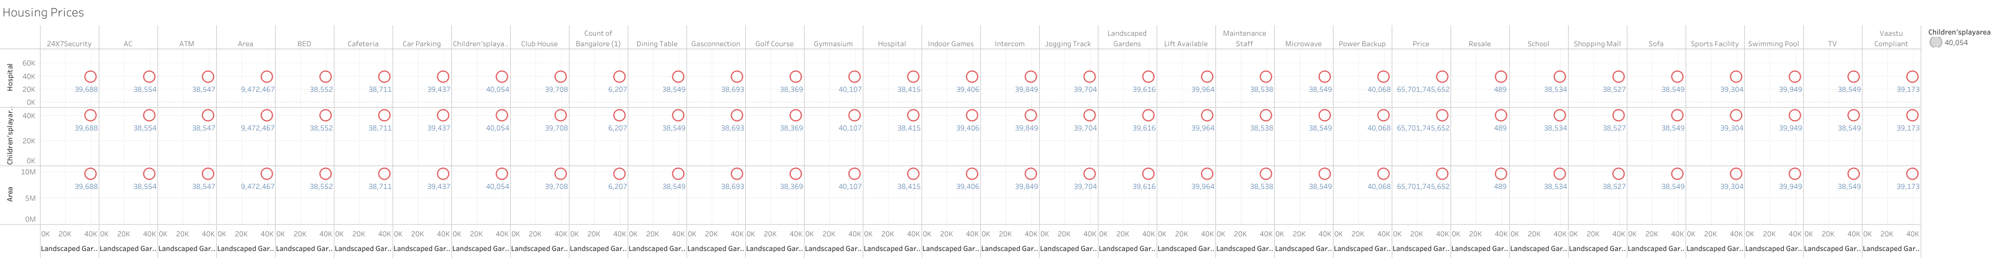

* **Clipboard values**

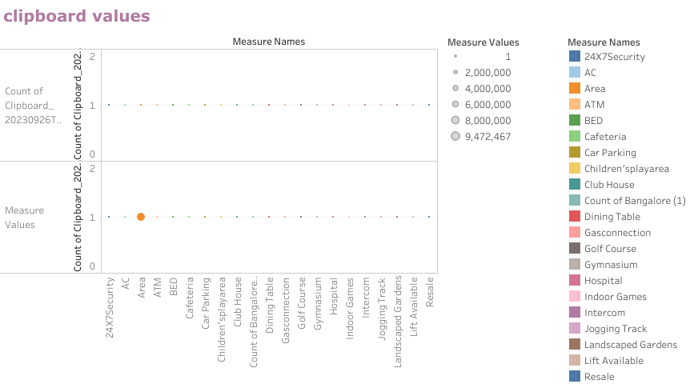

* **Staff quarts**

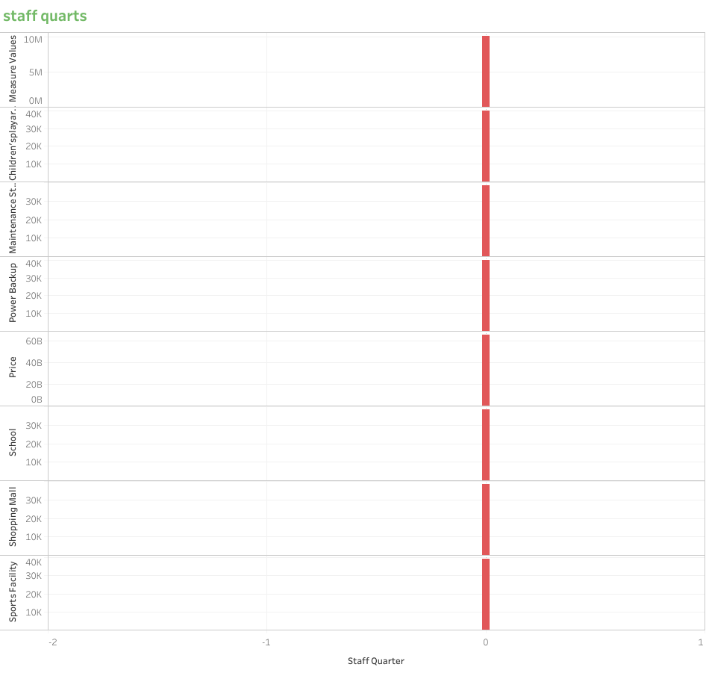

* 1. **Dashboard**
* **Dashboard 1**

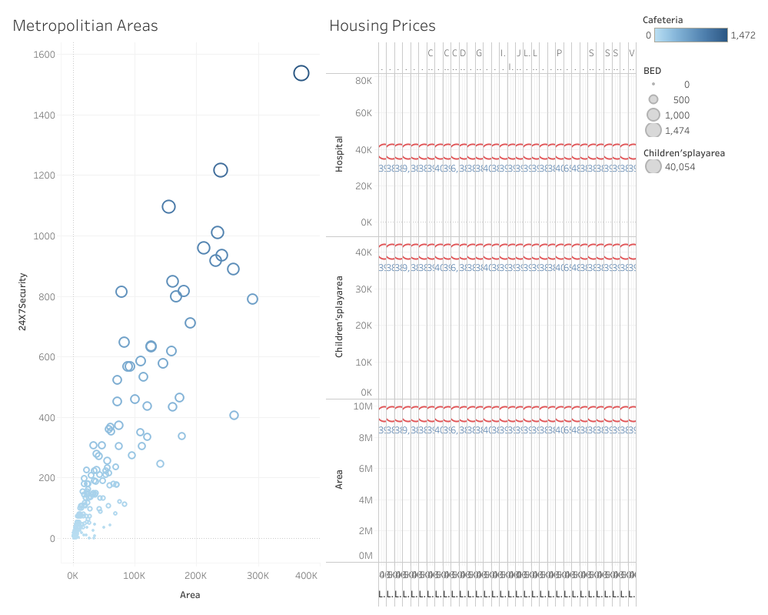

* **Dashboard 2**

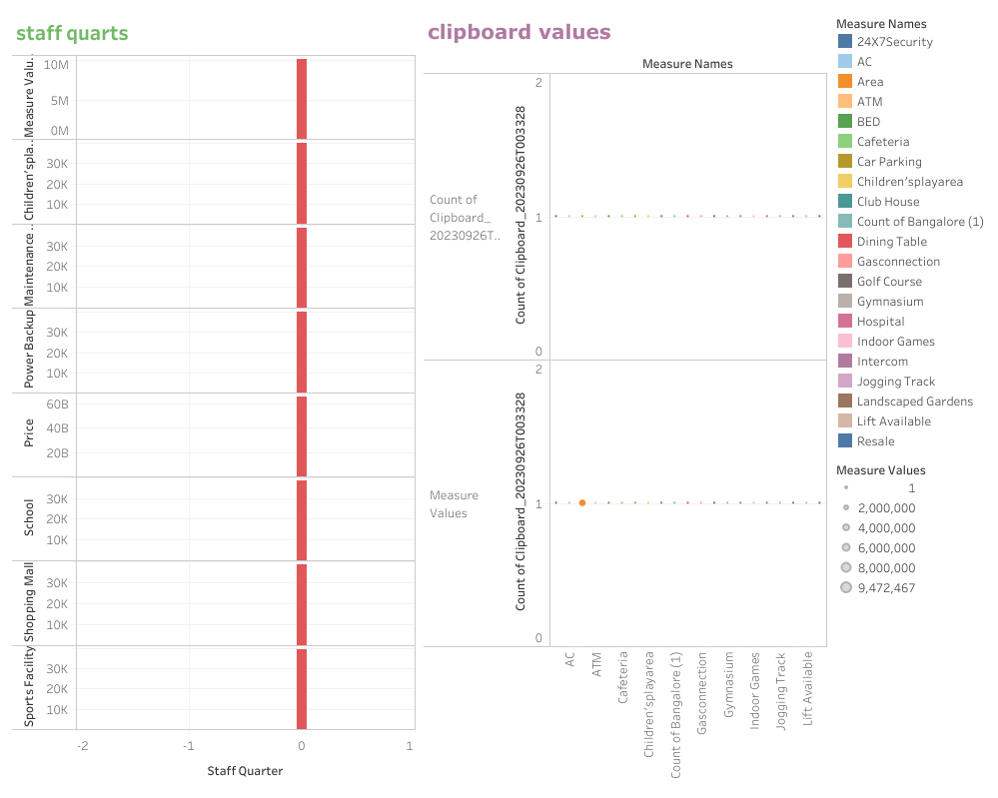

* 1. **Story**

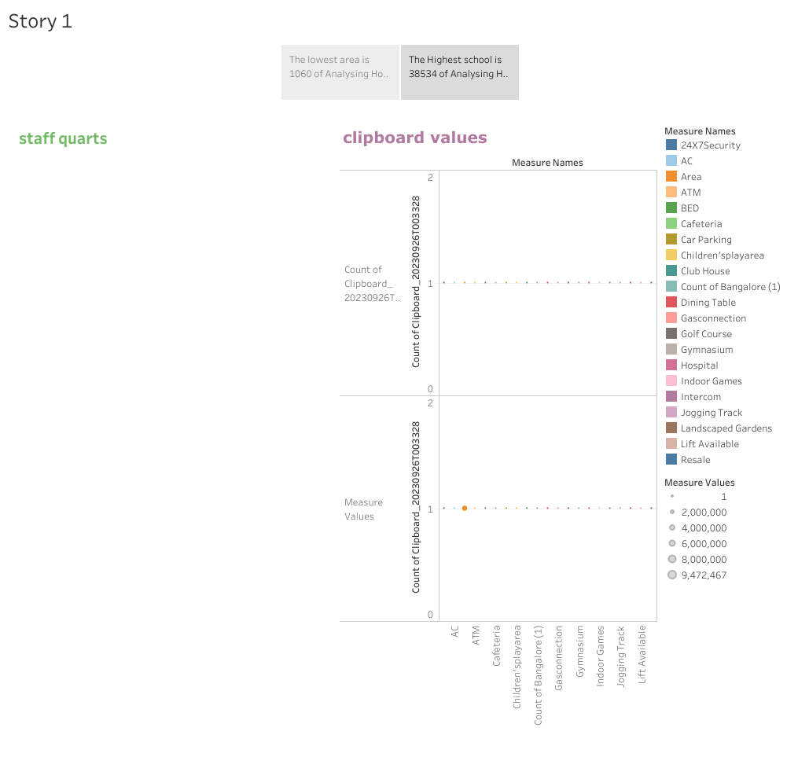

1. **Advantages & disadvantages**
   1. **Advantages**

* **Conveniences for comfortable living:**

Metros are perceived to be the first cities to have latest in the market luxuries. Adapting from free Wi-Fi to air from a shopping conditional buses and from a shopping complex to an ATM at every nook and corner. All these conveniences make occupancy comfortable in metro. Metros also guarantee decent connectivity via several public transport systems comprising road and rail. For recreation, the city would have considerable shopping,eating out, fitness, and other agile activity centers. It also has well provided healthcare centers too. Though cities beyond metros have these installations there are not too many and even within a stones throw.

* **Promising career opportunities**

Metros are known to provided substantial job opportunities to the many and across varied categories. For the planning ton seek new boulevards or study along with work, then definitely metros could be your preferred choice.

* **Higher Return On Investment (ROI):**

For those planning to capitalize on real estate, metros could be your preferred locale. Regions in metros that are up and succeeding, enjoy decent connectivity and are in the vicinity to commercial centers tend to be high ROI generating locations. The current world class infrastructure and the growth of new usually oversee price appreciation yielding high returns on yours.

* 1. **Disadvantages**
* **Cost of living :**

To avail of the best in the class conveniences and to converse a standard of living in a metro city could be hard on the pocket. For example,for a price, you purchase or just renting a 3BHK apartment in a city beyond metros you could barely get a 1BHK in the metros.

* **Stressful life:**

Life in a metro is recognized to be busy ever moving,rigid and stressful. With everyone fighting to be in the business with traffic twists and pollution afflicting the metropolis, it can be hard for some to with stand. Notably, the elderly in fact according to a survey by the office for national expectancy.

* ****Scarcity of Resources:****

Metros have a high density of population. As an outcome, critical resources are scarce. Accordingly, putting intense pressure on these resources which comprise water, electricity, among others.

* ****Pollution:****

Pollution is an awful existence for big city life and one of the most significant flaws. It would always sadden me when I would drive into the city for a job in the dawn in the summertime and gaze a large cloud of smog hovering over the downtown skyline.

Unfortunately, pollution may continuously be an issue in the big city regardless of the undertakings made to lessen pollution such as the signs on the road asserting to not fill-up on gas or trim your yard until after 6:00 p.m.

* ****Crime:****

There is continuously more crime in a big city, resulting in you reconsider your decision for possession in a big city. You are much more inclined to be a sufferer of a crime living in a big city than in a little town. This one must take proper care while walking on a road alone in a metropolitan city after the sunsets.

Indian cities are great havens for awareness, culture, and social life. Vibrant cultures are originated in cities because it holds a significant population to aid museums, concert halls, sports teams, and nightlife districts. Cities also offer rich social openings. People in rural areas admire only restricted social opportunities because of the small regional population. City inhabitants can decide on their pals and mates from among a large number of people of related curiosities and inclinations.

But we can’t let go of the fact that India is often considered as one of the primarily unlivable countries in the world. This isn’t tough to assume, deeming the intensifying incidents of pollution, rape, crime, traffic, and everything that makes a place horrible. The truth remains that the cities that accomplish as the face of the country themselves need instant makeovers, in terms of ideologies, principles, and many other aspects. Our cities make life depressed for some individual or the other, and sometimes people think its time to shift out to less commercial and small communities instead of harming their health and mental consensus in these cities!

### ****Here is a brief discussion about the life of people in these 5 metropolitan cities :****

### NCT of Delhi

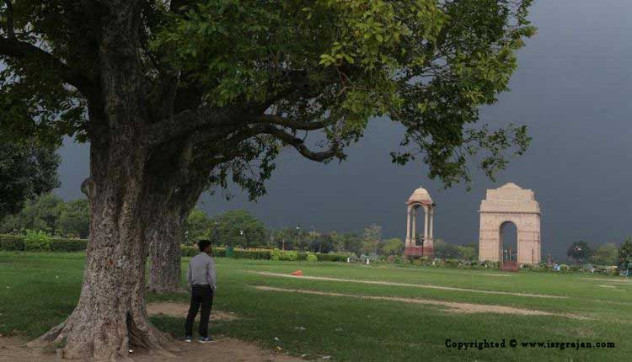

India has one of the fastest-growing population rates in the world and a retail presence that is boosting promptly. At 5.8%, its GDP growth is second just to China. And the capital city of the country, New Delhi is, thus, a city of opportunity for Indian residents and ex-pats likewise. Also, no country has excess youthful people than India (about 600 million people, i.e. more than half India’s population, are under 25 years old). Sometimes it looks like they are all here in the capital city New Delhi. The city is undoubtedly fascinating, cosmopolitan, sophisticated, and full of vows. No surprise young people are thrilled here like anything.  
As with any ex-pat metropolis, you can find luxurious places to dine and hang around if you look hard enough. The local economy has not been slow to report that ex-pats come equipped Also, no country has excess youthful people than India (about 600 million people, i.e. more than half India’s population, are under 25 years old). Sometimes it looks like they are all here in the capital city New Delhi. The city is undoubtedly fascinating, cosmopolitan, sophisticated, and full of vows. No surprise young people are thrilled here like anything.  
As with any ex-pat metropolis, you can find luxurious places to dine and hang around if you look hard enough. The local economy has not been slow to report that ex-pats come equipped with compensation packages that hinder the typical local incomes, and there are some incredible (and accordingly pricey) ex-pat villas in select suburbs like Vacant Vicar, Defence Colony, Golf Links, Sunder Na gar, and Jo Bag.

For the usual ex-pat, however, it is a cheap place to live. It is no confidential that Indians like spicy food. While you may also like curry, your Western equivalent is probably a dull imitation of the real thing. Ask any Indian ex-pat in Europe, for example, and they will tell you that most Indian food is tedious in comparison with what they get back home.

.

.

For sure, it’s not merely about the curries. Most ex-pats urge against drinking tap water. Again – you’re not used to it, and waterborne diseases such as typhoid are a substantial risk, with hygiene levels in some areas below the norms expected by most ex-pats.  
Talking about the pollution level in the country.

One unavoidable consequence of this is a lot of automobiles and minimal fresh air. According to the World Health Organization, New Delhi is the world’s sixth most polluted city. In January 2019, a plunge in wind speed and temperature led to a remarkable ‘smog’ swooping in the city.

Underprivileged sections of the population were forced to burn wood to stay warm, thus making the situation even worse. This combination led to pollution levels of 500 (on the PM 2.5 scale). Speculate in mind that the US Government acceptable levels are merely 35.  
We can’t let go of the fact that it is the most precarious place for women. A recent study operated by UN Women showed that 95% of female New Delhi residents feel ‘unsafe’ in the city’s civic areas. A Thomson Reuters research found that India was the world’s least safe place for women. And yet Indian society is not as male-eccentric as numerous others.  
The equal rights of women are cherished in the nation ’s constitution. Nonetheless, as some notorious events have highlighted over the past few years, New Delhi’s streets are not safe for women to walk alone.

### 2. Mumbai

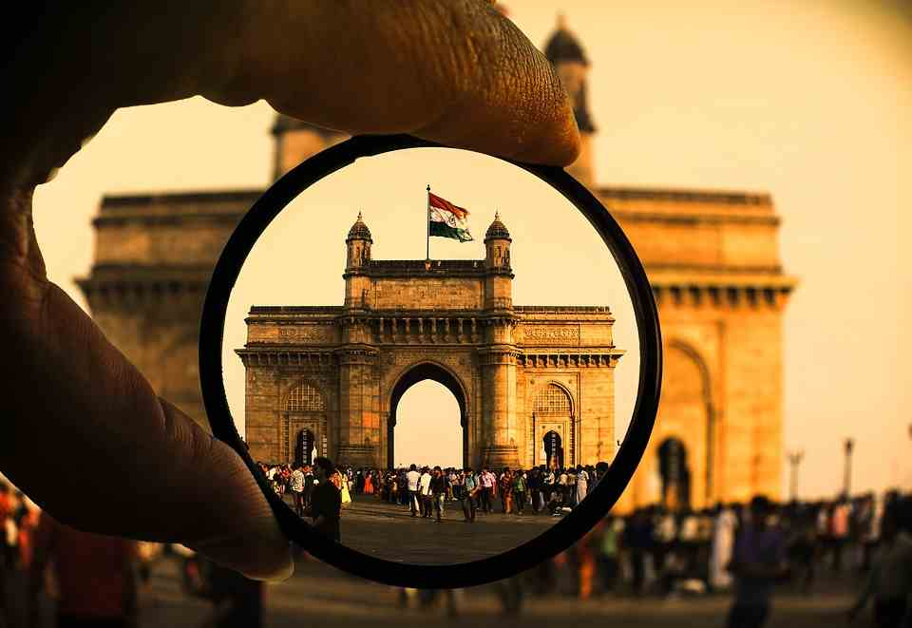

You don’t live in Mumbai, and you strive, every day 24x7x365. For years, there has been a dispute over which is the better city to live in India: Delhi or Mumbai. While Delhi might win against Mumbai in terms of the comfort it gives, the city of dreams has its stature, and it lets you do what no other place would. It enables you to dream. Amid-st all those huge buildings trying to touch the sky, you’ll disclose thousands of small homes. Some the size of lavatories in Delhi but you’ll never find a gloomy face among them because every single person reckons that they will make it big one day.

The city has a remarkable nightlife, career opportunities for those who persuade to dream and the broadband in Mumbai are just how life is: exceptionally fast. So, here we try to determine if it is an excellent place to live in by evaluating both the pros and cons of residing in the city.

****Pros of Living in Mumbai****

1. It offers top-quality healthcare facilities. Mumbai has some world-class hospitals that render treatment at reasonable rates. People flee from different parts of the world to get medications here.

2. It is an educational hub. Many schools provide good elementary education, and it also has several reputed colleges, universities, and institutions.  
Anyone can see it big here. You get respect irrespective of your caste, creed, colour, gender or economic status.

3. Mumbai is exceedingly safe. The city never slumbers, and girls don’t have to worry about staying out till late.

4. It is an amusement for shopaholics. You can buy a variety of items from the inexpensive street markets to the high-end showrooms.

****Cons of Living in Mumbai****

1. When you are inhabiting in Mumbai, traffic is your biggest foe. The roads of the city have lagged to cope up with the increasing number of automobiles on them, and to watch so many people walking on them is highly troublesome.

2. Property rates are more than most of the other metropolis in the country. Since it is an alongshore city and scatters over a long stretch, you might find a decent place by putting in some effort though. If your income is ample, then investing in real estate shouldn’t be a hardship at all.

### 3. Bangalore

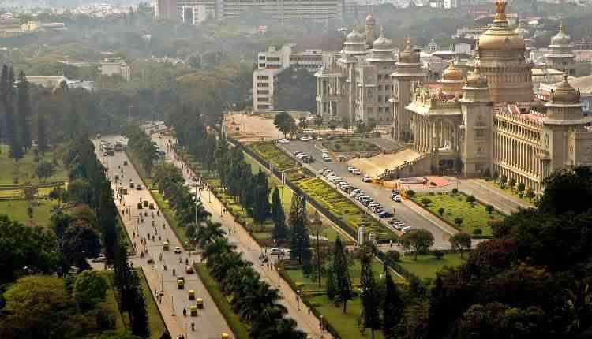

Bangalore is the capital of Katakana, an Indian state Located on the Deccan Plateau. Bangalore is ranked 5th among India’s most populous city and is well recognized as the centre for India’s information technology and industry sector. It is ranked among the top 10 best entrepreneurial locations in the entire world. Bangalore is a vast and rising metropolis and home to many prestigious colleges and research institutions in India.  
The city is also known as the Silicon Valley of India. Due to its large industries and an extensive range of other manufacturing sectors, Bangalore has fascinated a wide range of nationalities. Bangalore is also the second-fastest-growing IT products exporter and metropolis in India.

****Reasons to live in Bangalore:****

1. Companies – Bangalore is home to numerous companies that are deliberately making a name for themselves. One well known Indian Company that is making its existence known is Infernos. Infernos has its headquarters located in Bangalore; IT companies that also have their headquarters located in India are Bharat Electronics Limited. There are also numerous Aerospace and Aeronautics Company located in Bangalore. The Indian Space Research Organization, Hindustan Aeronautics Limited and National Aerospace Laboratories all have their headquarters located in Bangalore.
2. Climate – Bangalore has a tropical savanna climate. The city’s climate is portrayed by erratic wet and dry seasons. Because of its high elevation, Bangalore has a moderate climate throughout the year. The coolest month is December with an average low temperature of 15.4 degrees Celsius and the hottest month is April, with an average temperature of 32.8 degrees Celsius.
3. Educational Institutions – Bangalore is home to several prestigious and high-end universities. The Indian Institute of Science is placed in Bangalore; it is the steering institute for science and research in India. Most of Bangalore’s universities are social. Some of these universities include the National Center for Biological Sciences, the National Institute of Design, and the International Institute of Information technology. Bangalore also possesses the best health institutions and medical schools in India.
4. Economy – The multiple IT and research companies located in Bangalore are certainly one of the prominent sources of earnings for people who are residing and labouring in the city. These companies not only give job opportunities for Indians; they moreover allow Indian locals to nurture skills regarding manufacturing and design. Silicon mining is also a promising source of revenue for the Bangalore government.
5. Fewer Traffic Jams – Bangalore has a low vehicle score compared to other European and American cities with similar financial and manufacturing capability. This centres that living in Bangalore is smooth because you won’t have to waste plenty of time in rush-hour traffic.

****Reasons not to live in Bangalore:****

1. Overcrowding – Bangalore’s population in 2011 is recorder at 8.5 million. A gigantic number of people compared to its extent of only 741 square kilometres. Overcrowding issues can be the reason for significant health problems which can be potentially harmful.
2. Pollution – Bangalore’s government are peeking for solutions to expunge the 3,000 tons of solid waste material yielded every day. Unsanitary exercises in disposing of solid waste have been the reason for environmental pollution throughout the city. Now, Bangalore’s administrators are gazing for a productive and environmentally-safe way to alleviate the enormous amount of solid waste material generated every day.

**4.Chennai**

While the rest of the metropolitan area at least happening, Chennai takes the cake of being the least happening city in the country. Cultural events clear out the city, and the natural heritage is dispiriting. If you’re a regular auto-rickshaw user, get prepared for some racist aftermaths and some empty wallets if you want to survive here. The heat is something that slays you, not to mention how filthy it is.

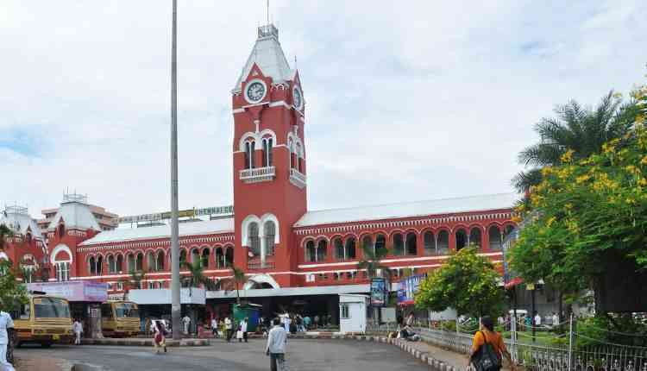While the rest of the metropolitan area at least happening, Chennai takes the cake of being the least happening city in the country. Cultural events clear out the city, and the natural heritage is dispiriting. If you’re a regular auto-rickshaw user, get prepared for some racist aftermaths and some empty wallets if you want to survive here. The heat is something that slays you, not to mention how filthy it is.

**5.Kolkata**

This city is best described as sluggish as a sloth. While the locals have very decisive views about their city and other things, this “city of joy” isn’t as joyful for outsiders. The nightlife squashes all norms of nightlife in a metropolitan city. People deny working in this city –control. 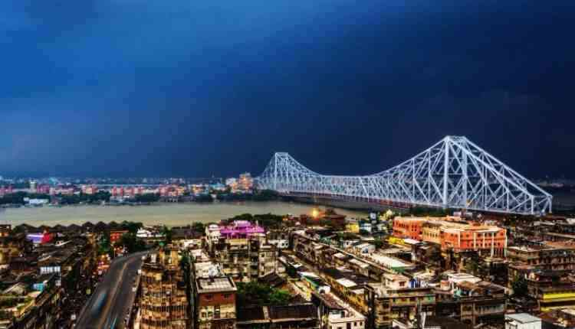

**6.Application**

Housing price prediction help the developer determine the selling prices of a house and can help the customer to arrange the right time to purchase a house. There are three factors that influence the price of a house which include physical conditions, concept and location.

* **Data collection**
* **Pre- processing**
* **Data analysis**
* **Application of algorithms**
* **Evaluating the models**
* **Housing prices**
* **Metro politician areas**

Our main task is to create a model which will predict the price f any hose by looking at the features. We have data set of house prices with some features like no.of bathrooms, no.of bedrooms,etc…..

**6.Conclusion**

The “Analyzing housing prices metropolitan of area in India” project successfully utilized tableau to analyze spending behavior, identify opportunities for real world problem. There are real world problem that can be with machine learning. Some of these be solutions can take very accurate predication that can be leverage the power of machine without being data scientist when easy to use applications are built around some of these complicated models.

**7.Futures scope**

The futures scope of analyzing housing prices metropolitan area in India using tableau is likely to be catheterized by advancements in AI , real time analyses ,data security and improved users experiences.

**8.Appendix**

A.source code



